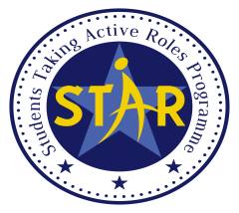

LINGNAN UNIVERSITY
Office of Global Education
STUDENT EXCHANGE PROGRAMMES - FOR OUTGOING STUDENTS
PRE-EXCHANGE GOAL-SETTING FORM

- Personal Particulars
Name
Lingnan Student ID
Programme & Major/ Stream
Year of Study in 2023/24
Term of Exchange
Host Institution
Host Country

- Goals and Action Plan
(a) Please set goals for your exchange in EACH of the following aspects and (b) action plan to achieve these goals. (Not less than 50 words for each aspect)

- Academic Experience
- Goal(s)
- Action Plan | (Not less than 50 words)

- Cultural Exposure
- Goal(s)
- Action Plan | (Not less than 50 words)

- Social Experience
- Goal(s)
- Action Plan | (Not less than 50 words)

- Professional Development
- Goal(s)
- Action Plan | (Not less than 50 words)

- Personal Development
- Goal(s)
- Action Plan | (Not less than 50 words)

- Difficulties and Challenges
Please anticipate the difficulties and challenges you would encounter during your exchange. (Not less than 100 words)

How would you prepare yourself to these difficulties and challenges? (Not less than 100 words)

Signature:_______________________ Date:___________________

